## How To Access Google Code SubVersion(SVN) Server

This is a brief tutorial to access Google Code SVN Server. Google Code is very fast and reliable for SVN Repository.

[***Subversion****(****SVN****)*](http://en.wikipedia.org/wiki/Subversion_(software))*is a version control system initiated in 2000 by CollabNet Inc. It is used to maintain current and historical versions of files such as source code, web pages, and documentation.*

I am using one of the sample project that have been done for NUS ISS M.Tech Course. ARS.Net is a simple program for Flight Reservation. Database structure and content are inspired from SAP sample of S_FLIGHT.

Like other services from Google , Google Code required Google User name and password, with some notes:

* username = gmail username without @[gmail.com](http://gmail.com/)
* password of Session = Login to Google services (e.g gmail) firstly to keep session in browser and next goto App. SVN url e.g <http://code.google.com/p/arsnet>
* SVN password = SVN Client will use this password to authorize user to access SVN Server.

SVN password can be found under Settings link , see picture below:

[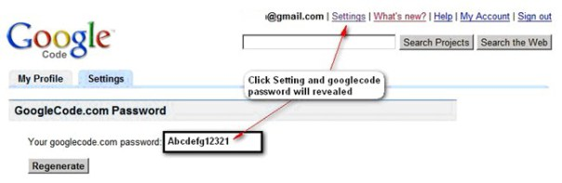](http://devwatch.files.wordpress.com/2008/10/svngc_01.jpg)

One of powerful and fast SVN Client is TortoiseSVN which can be downloaded on<http://tortoisesvn.net/downloads>.

Below is step by step to use SVN Server of Google Code. The End target is we can do a check out and check it of SVN.

**1. Create Workspace Folder and Checkout SVN**

Create a folder using Windows Explorer, right click and choose SVN Checkout…

[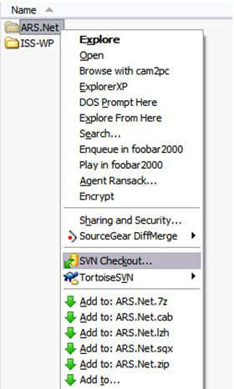](http://devwatch.files.wordpress.com/2008/10/svngc_02.jpg)

TortoiseSVN will ask an url, type an Application Project svn from googlecode, e.g<https://arsnet.googlecode.com/svn/trunk/>. On checkout directory enter workspace location which created on Step 1 e.q: D:\workspaces\VisualStudio.Net\ARS.Net

[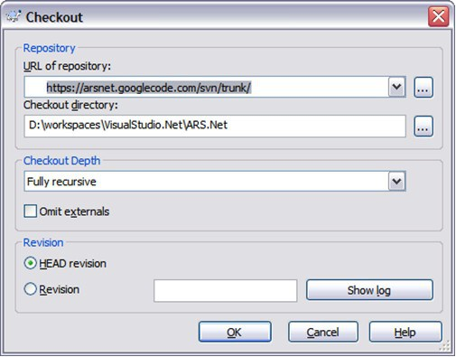](http://devwatch.files.wordpress.com/2008/10/svngc_03.jpg)

2. Setting up Firewall Proxy (optional)

This step is optional, if there are any firewall existed, it is needed to define a proxy and port for TortoiseSVN to access internet

[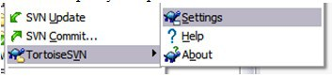](http://devwatch.files.wordpress.com/2008/10/svngc_04.jpg)

[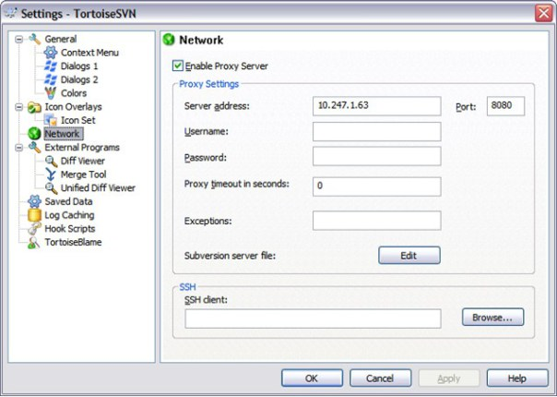](http://devwatch.files.wordpress.com/2008/10/svngc_05.jpg)

**3. Checkout SVN** **and User Authentication**

If TortoiseSVN is succeeded to connect to google code, It will required to key in user (w/o @gmail.com) and SVN password (see Step1 to retrieved a SVN password). Tick Save authentication checkbox so it will not keep asking user/password for every Checkout.

[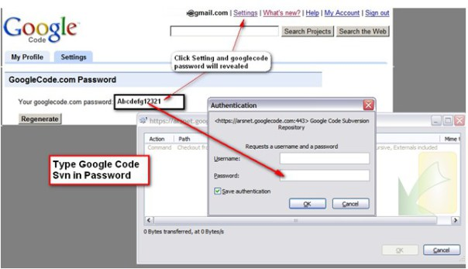](http://devwatch.files.wordpress.com/2008/10/svngc_06.jpg)

**4. Add File or Folder to SVN**

To add file or folder to SVN , on folder/file right click press TortoiseSVN – Add…

[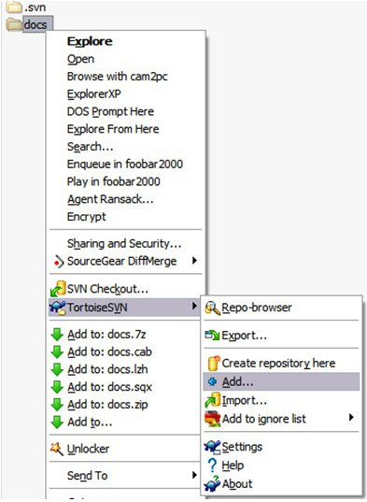](http://devwatch.files.wordpress.com/2008/10/svngc_071.jpg)

Select folder or file to be added

[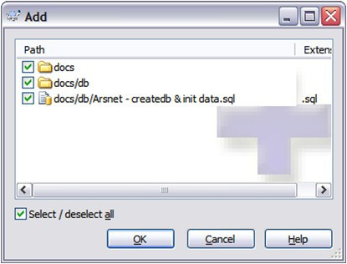](http://devwatch.files.wordpress.com/2008/10/svngc_08.jpg)

If it is success on add, it will show the result. but the concrete file is still not in SVN Server.

[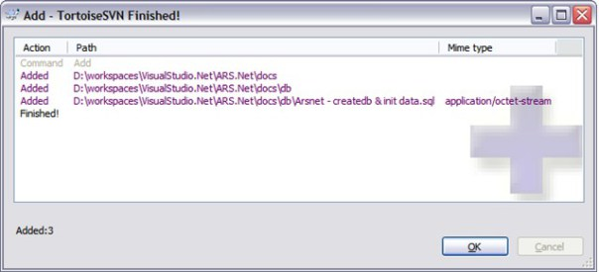](http://devwatch.files.wordpress.com/2008/10/svngc_09.jpg)

**5. Commit Changes**

Every operation on SVN Client such as Add or modify, SVN requires to commit to send a file to repository server.

[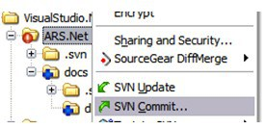](http://devwatch.files.wordpress.com/2008/10/svngc_10.jpg)

It is a good practice to give an informative comments.

[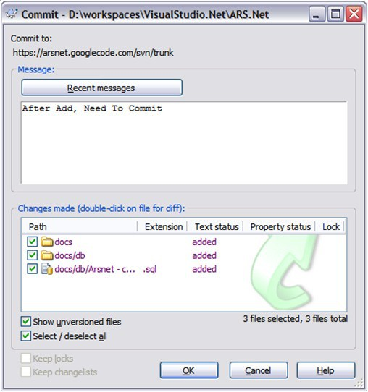](http://devwatch.files.wordpress.com/2008/10/svngc_11.jpg)

Commit is succesfully done.

[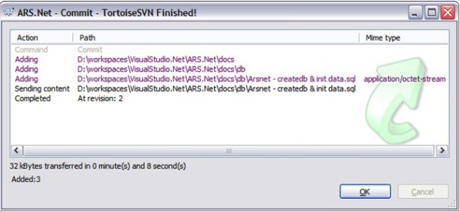](http://devwatch.files.wordpress.com/2008/10/svngc_12.jpg)

With these few steps, you have done a basic use of SVN repository (standar operation that frequently done).

**Accessing Google SVN from behind Proxy**

For accessing SVN from behind firewall proxy, you need to know what is your proxy addess, port , user id and password. Usually this information can be found in your browser setting like IE is in menu Tools – Internet Options – Connections Tab – LAN Setting .

The way to add proxy setting, is right click on SVN folder and from context choose Tortoise SVN – Settings as seen below:  
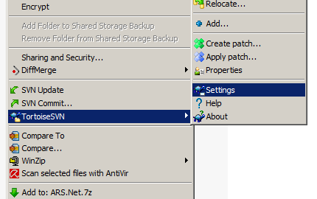

And from Tortoise SVN setting choose Network [1] and check the Enable Proxy Server[2], write down the information which you have in Browser proxy recently[3]. Some times a proxy is without user id or /password, then in this case just left it blank.

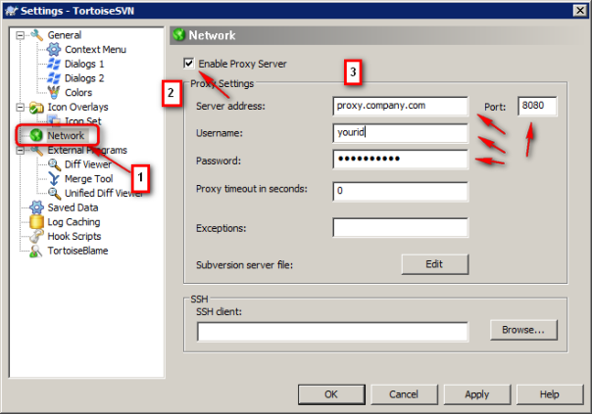

**Clearing Authentication Cache.**

This TortoiseSVN – Setting is to clear SVN user id/password after you authenticate it. It is very useful if one computer is used by more than 1 SVN user id. In Settings , choose Saved Data, click button Clear on Authentication data.

